College application advice

Revised 1st-edition, 2023-2024 :D

[Sharing link:](https://docs.google.com/document/d/16vFvYwA0vxkRWyTnYrtcjviCCmgNb6iNGhXBo9HYFHA/edit?usp=sharing)   
  
Updates/additions:

-TLDRs for specific sections  
-Essay-cutting advice  
-Essay writing time management section  
-Inverted Pyramid concept explanation  
-school database section analyzing acceptance rates by major  
-additional essay and Letter of rec resources  
Section about asking “mentors” for a letter of recs a section about applying as a humanities major strategy  
-Reflection questions and tasks checklists

*Take everything here with a grain of salt as everyone’s college application experience is different so what worked for me may not work as effectively for you. Following my advice is not a guarantee that you will get into any of the schools I got into either.

And you will hear this after you commit to a school but I’ll prepare you all early: **College is what you make of it!** How will you respond if you don’t get accepted into your top school? Do you complain or take advantage of the opportunities presented?   
(This will make more sense after decisions are released)

My advice is based on personal experience but also advice I found online, and received from other people, such as adults and current collegiate students.

Everything linked is something I personally used as well, with the exception of a couple of items. But I wouldn’t share anything if I didn’t think it would be helpful.

**But ask other people for their tips/insights as well!!!!!!**

Contact info if you have any questions, want me to edit your essays, want to tell me a joke, send memes, etc :)

Anyway, I hope this document aids you in your college admissions journey 🙂

Email: [bjng1@uci.edu](mailto:bjng1@uci.edu)

LinkedIn: <https://www.linkedin.com/in/brandon-ng10>

Discord: brandng10   
Instagram: Brand0n.Ng

Discord>Instagram for texting

Table of Contents

Click on any subject line to jump to that section.

**Background info: 3**

AP classes and scores 4

Extracurriculars: 4

**Schools applied to: 5**

**College application advice: 6**

Non-academic factors to maybe consider 8

School research checklist 9

Look beyond the big names 9

Specific examples: 10

Know the school’s application deadlines! 11

Categorizing schools (safety?, match?, reach?) 11

School databases 14

Sites to look for admission data 15

Know the various applications! 16

Filling out the extracurricular/activity list section 16

Submitting Test Scores 17

Considerate financials! 17

Applying Early Action/Decision or Regular Decision. 18

More insight into decisions: 19

**Essays: 21**

**Things to know 21**

Brainstorming topics: 22

Figuring out what to write. 22

Essay Content Insights: 22

Starting the essay: 23

Why Us essays 23

Expanding on your extracurriculars 24

Writing style: 26

How you write>what you write about 26

Writing strategies: 27

Intro 27

Body Paragraphs: 28

Conclusion 28

The Inverted Pyramid 29

Cutting tips 29

Making essay writing time: 30

Additional tips 31

Essay resources: 31

**Letters of Recommendations (LOR’s): 32**

Asking teachers 34

Asking counselors 34  
Asking “Mentor” figures 34

**Other misc tips/insights: 35**

Utilize the resources around you! 35

A sneaky way to (maybe?) slightly improve your chances at admission. 37  
Putting down an alternative major 37

ChatGPT? 38

Build a support system 38

Final thoughts 38

**Additional resources: 39**

But before all the advice, here’s a reminder: Community College is a great option as well!

# Background info:

To get to know who I was as an applicant and get a sense of where my advice is coming from.

Lowell HS class of 2022

San Francisco, Ca

Class Ranking: N/A

Unweighted GPA: 3.85. Weighed: 4.0

UC GPA. 4.05

-[How to calculate UC/CSU GPA](https://admission.universityofcalifornia.edu/admission-requirements/freshman-requirements/gpa-requirement.html)

College: the University of California, Irvine (UCI)  
Admitted for BA in Environmental Science and Policy

Major: BS in Earth System Science, Minor: Urban Studies

## AP classes and scores

Taken during junior year

AP Language and Composition: 4

AP Environmental Science: 4

*Taken during senior year (still relevant because some schools may ask for which classes you are taking fall semester)*

AP US Gov and Politics: N/A (5)

AP Comp gov and Politics: N/A (5)

AP Human Geography: N/A (5)

SAT or ACT: N/A

## Extracurriculars:

*This is a condensed version, not word by word what I put on my apps

I cut out the descriptions of what I did since that’s not what you're here for but this is just to get a general sense of what I did outside of the classroom.

**Eco Club**

Participation length: Freshman (2018) -present (senior year)

Leadership roles:

* Secretary; Sophomore (2019) -Junior (2021)
* Co-President; Senior (present)
  + Co-President: present
  + Secretary: 2019-2021

**TedEd Club**

Co-President: 2019-present

***Work experience***

**Summer Day Camp, Young Leaders’ Camp (SDC YLC)**

Leadership Role: summer camp counselor

Participation length: 3 years (2019-2021)

* 2019, 2021, worked with 3rd & 4th graders
* 2020, worked with 6th-8th graders

**Help U Learn (HUL)**

**Leadership role:** supervisor

Participation length: September (2021)-present

· Supervise and assist 3rd-5th graders with their homework.

· Oversee and manage a group of 3-6 tutors.

***Other***

**The Lowell ( student-run newspaper)**

**Leadership roles:**

* Sports Editor: August (2021) - present
* Reporter: Sophomore (2019) - Junior (2021)

**Piano lessons : 7 years (2014-present)**

Lessons taken at the Amabile School of Music

* Studies Music Theory and various forms of piano music, ranging from classical, modern and pop music
* Lessons one day a week for 30 minutes

# Schools applied to:

All regular decisions, No Early Action or Early Decisions.

| Accepted | Waitlisted | Rejected |
| --- | --- | --- |
| **[UC’s]** Irvine Merced Riverside  **[CSU’s]** SJSU Chico State  **[Out of state]**  CU Boulder | **[UC’s]**  Davis  Santa Cruz San Diego  **[CSU’s]** Cal Poly Slo Long Beach  **Private** Santa Clara | **[UC’s]**  Berkeley UCLA Santa Barbara  **Private**  Boston University |

# **College application advice:**

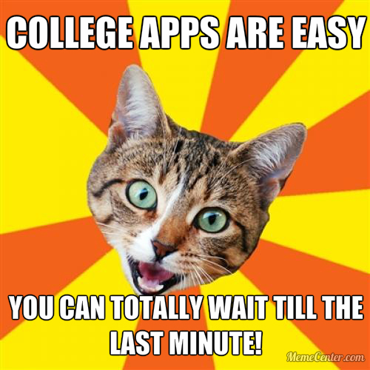

Tip #1: Start early, as in RIGHT NOW!

Start in the summer. Maximize how much time you have. If you haven’t/didn’t, then DROP EVERYTHING AND START RIGHT NOW!

Yes, you will still be stressed in the fall but you won’t be as stressed relative to your peers who didn’t start until in the fall since you have a head start.

**Researching schools**  
  
**TLDR**: Research if the school will suit you based on programs, opportunities, location, size, etc

This is cliche but it’s very true: find the **BEST** school for **YOU**

**The “best, most prestigious” schools may not be the BEST for YOU  
Big name doesn’t always me “Best”**

**How do find the best school for you then?**

Ask yourself

1. Does the school have my major? (what’s the point of applying if they don’t have a program for what you want to study?)
2. Does the program for my major look strong and appeal to me?
   1. Just because a school has your major, doesn’t mean the program is the greatest nor may it be the best for you. Ex. I didn’t apply to USC or SDSU even though those are great schools because their environmental science programs didn’t really appeal to me.
3. Is school a right for me? How do I see myself fitting in here? Do I feel I can succeed here?  
   It-Somewhat important to know for out-of-states/privates if they have a “why us” supplement essay. ( more on that in the essay section).

Things I looked for in a program:

1. Course description and learning goals
2. Courses offered within the program.
3. Internship and research opportunities.

Just because a school may be known to be strong in certain subjects, look into the program and see if their program suits you!

On the flip side, some departments within the school may not be well-known but are strong!

Ex. UCI’s Department of Earth Sytems Science is highly acclaimed within the scientific community and was the first-ever department of its kind established. Cal Poly SLO is famous for its engineering program but they also have a really strong CS and business program.

Cornell also has a really strong college of agriculture and environmental sciences, even though Cornell is not necessarily known for that.

This can be especially helpful if you want to pursue a career that usually requires attending a post-graduate school (nursing, law, teaching, business, etc) since some schools, offer 4-year programs that allow you to skip a post-grad education.

This is especially helpful if you want to enter the medical sector because you could have a more direct path into becoming a nurse, other medical-related fields, etc since you’re not taking a pre-med route but are learning the skills and subjects needed to get a job!

EX. Univ of San Francisco has a 4-year Nursing program. UCI offers the Calteach program, where you can get a degree AND a teaching credential in 4 years.

## 

## **Non-academic factors to maybe consider**

Now, questions to ask if you want to go really deep into research. But really, this stuff is more for people who have a more holistic view of college and care about factors beyond the academics, such as location, culture student body size, etc. If you care only about academics, good for you!

Ultimately, use these to help you find schools where you think you would succeed at!

To me, College is an experience so I pondered these questions a lot.

1. Location: Rural, suburban, Urban? City vs small town? Which setting do I like?

-How accessible are internships in the area? How many internship opportunities are available? Are there a lot of companies nearby that do work related to my major I could potentially intern for?

2. Size of the student body? Do I want a smaller, tight-knit community where I can be closer to my classmates and my professors (advantage of private schools) or do I want to be with a lot of people?

Also can be seen as small fish in a big pond vs big fish in a small pond scenario.

Do I mind being with more people, even if I would prefer a smaller community? I personally asked myself this quite often.

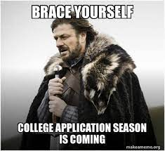3. Culture: Party culture? Competitive and cutthroat culture quiet, no social life culture? Is there a lot to do or is it quieter? Big on sports? Lots of school spirit or little?

What type of environment do you want to be in? What type of students do you want to be around?  
Are students involved in things on campus? How active are students in participating in organizations? Lots of student-led events occurring?

Apply only to schools you would seriously consider attending! What’s the point in applying if you don’t think you would go?

Don’t waste your time, money, and resources on applying to those schools! (more on the money aspect below)

Ultimately, find schools that you think you could **SUCCEED** at!

## *School research checklist*

* **Is my intended major offered?**
* Does the program for my major appeal to me? Does it suit my interests?  
  Does the program have what I’m looking for?
* Where is the school located?
  + Is it Rural? Suburban? City?
* How large is the student body?
  + What is the average class size?
* What is the school culture like?
* **Do I want to attend this school? DO I feel like I can succeed here?**

## **Look beyond the big names**

There are plenty of schools that are not as well-known but are fantastic! keep your options open!

Some general examples, CSUs, Private and liberal art schools, HBCUs, etc

(it’s ironic this is coming from a UC student like me)

[Liberal arts colleges explained](https://www.usnews.com/education/best-colleges/articles/2018-12-07/what-a-liberal-arts-college-is-and-what-students-should-know)

[Great video explaining the differences between the CSUs and UC's](https://www.youtube.com/watch?v=LneaGNQxUsE)

[-Breakdown of the CSU’s](https://youtu.be/v4PnA7L7G0U)

[-Breakdown of the UC’s](https://youtu.be/XR6C1r53iqg)

But if you don’t want to read the article/watch the videos…

**Summary of Liberal arts colleges**

-Smaller student body and class sizes, more tight-knit community

-Interdisciplinary curriculum. No matter your major, you’re exposed to a variety of topics, including but not limited to the humanities, STEM, social sciences, etc. Even if you’re pursuing a major that involves a lot of hard science, you will learn about the humanities as well.

-Learn soft skills that are needed in any career.

-$$$. Higher tuition but liberal art colleges generally offer more financial aid.

**-(just a con I’ve heard mentioned)**, Because of the interdisciplinary curriculum, you learn a lot but you may not learn all the skills or background knowledge you need to succeed when you get a job.

**CSU’s vs UC’s**

UC is more research-oriented while CSUs focus more on practicality and application of the material (more hands-on).

UCs are more expensive than CSUs,

CSU’s have smaller class size ratios.

9 campuses vs 23 campuses

UC offer 900 degrees whereas the CSUs offer 2700

UCs are more selective

UCs are generally more prestigious but CSUs are solid (and like I said above, “best prestigious, school” doesn’t necessarily it’s the best school for you).

(and some CSUs are quite strong in certain areas, even equivalent/better to UCs known for those programs)

Ex. Cal Poly SLO: Famous engineering and architecture program.

SJSU: Fantastic CS program (also in the perfect location for seeking internships and jobs as well)

CSULB, SFSU, and SDSU: Great Business program.

## 

## Specific examples:

[Claremont Colleges](https://www.claremont.edu/)

[Colleges that change lives](https://ctcl.org/category/college-profiles/)

Northwest 5 Consortium

Quaker college consortium

Massachusetts 5

University Innovation Alliance

And a closing tip…

## **Know the school’s application deadlines!**

Esp if you’re applying **EARLY** (more on that below)

## **Categorizing schools (safety?, match?, reach?)**

**TLDR**: Safety schools=scores are above the average percentile,

, match schools scores fall within the average percentile, reach schools=scores are below the average percentile

Now that you have a list of schools you’re applying too, it’s time to categorize them into 1 of 3 categories

1. Safety
2. Match
3. Reach

So what do they mean?

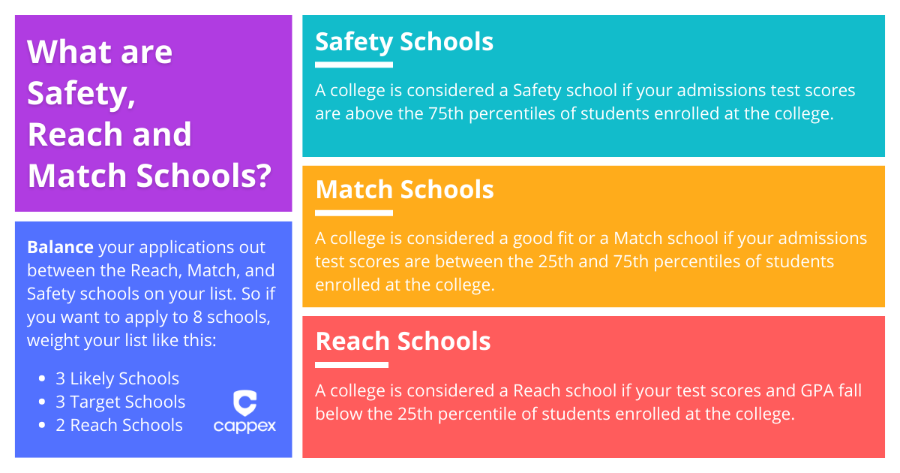

Avg Percentile usually means the scores of the middle 50% of students but there are some exceptions, like the UC’s use 25%-75% for their avg percentile data.

-Acceptance rates are also useful but there’s no clear rate that dictates whether a school is a safety, match, or reach because it’s subjective to you! Ex. a 60% acceptance rate for a school where you match the grades of those who are admitted may make it a match while to someone else, it may be safe while another school to that same person may say a school with a 35% acceptance rate is a match!

My advice: Figure out an acceptance rate that makes you confident you will be accepted to help you determine safe schools. Personally, I felt pretty good if a school has an acceptance rate of 60%+ so all the schools I applied to with acceptance rates over 60% were safe.

For matches and reaches, focus on how you compare to the average student who is admitted. It’s harder to determine based on acceptance rates so look at your grades/score first.

But focus on how your grades/test scores compare to the average admitted student.

**Looking closer at acceptance rates**

TLDR: Applying early has an advantage, certain schools/departments/majors have higher/lower acceptance rates

**Some** schools (not all) also break down admission data by the school your major falls under! This is helpful if you want to have a more precise look into how competitive it is to get into the school within the college your major falls under, especially if you’re pursuing impacted/competitive majors like Comp Sci, Nursing/Pre-med. Engineering, some Business programs, etc!

[Ex. Cal Poly SLO](https://www.calpoly.edu/admissions/first-year-student/selection-criteria/student-profile) (Based on Fall 2022 data)

Overall acceptance rate: 29%

Avg GPA: 4.08-4.25

By School:

**College of Engineering:**

GPA: 4.7-4.25

Acceptance rate: 21.9%

**College of Science and Mathematics:**

GPA: 4.14-4.25

Acceptance rate: 34%

**College of Agriculture, Food and Environmental Sciences:**

GPA: 3.94-4.25

Acceptance rate: 48%

Another example: [Santa Clara University (](https://www.scu.edu/admission/choosing-scu/class-profile/)based on fall 2022 data. Also a private school).

Overall acceptance rate: 53.9%

Avg GPA: 3.67

By School:

**College of Arts and Sciences:**

GPA: 3.46-3.84

Acceptance rate: 48%

**Leavey School of Business**

GPA: 3.58-3.87

Acceptance rate: 29%

**School of Engineering**

GPA: 3.60-3.91

Acceptance rate: 23%

## School databases

**Again,Some** institutions post their admission data publicly and may break it down by major, school, county, etc, (varies by school)  
Search [school admission data]. Data can be found on a school’s **institutional research** site*  
Very useful to actually see how competitive/impacted certain majors are:   
Examples using UCI majors

UCI general acceptance rate for Fall 2022: 21%  
(Fall 2023 Data breakdown by major hasn’t been released) **Business Administration**Applied 12,855  
Admitted: 1,127  
Acceptance rate: **8.8%  
Criminology, Law and Society**  
Applied 2,958  
Admitted: 663  
Acceptance rate: **22.4%  
Psychological science**Applied 1,160  
Admitted: 460  
Acceptance rate: **39.7%**  
*Some databases may be more extensive than others

[UCI](https://datahub.oapir.uci.edu/Data-Hub/Undergraduate-Admissions-Dashboard.php)

[UCSC](https://iraps.ucsc.edu/iraps-public-dashboards/student-demand/admissions-funnel.html)

[UCR](https://ir.ucr.edu/stats/admission_undergraduate)  
[UCLA](https://apb.ucla.edu/campus-statistics/admissions)  
[UCM](https://cie.ucmerced.edu/undergraduate-applicants-admits-enrollments)[SFSU](https://webfocus.sfsu.edu/ibi_apps/run.bip?BIP_REQUEST_TYPE=BIP_RUN&BIP_folder=IBFS%253A%252FWFC%252FRepository%252FIR_Public%252FAppsAdmitsEnrolled&BIP_item=AppTable.htm)

[SDSU](https://asir.sdsu.edu/admission-data/applications-by-major/)  
[CSU Long Beach](https://data.ir.csulb.edu/t/IRA-Public/views/UndergraduateStudents/AppliedAdmittedandEnrolledTrends?:showAppBanner=false&:display_count=n&:showVizHome=n&:origin=viz_share_link&:isGuestRedirectFromVizportal=y&:embed=y)

It can go both ways, so you may have a more difficult chance of getting in because of your major but also vice versa.

Anyway, a concrete example of categorizing schools from my list of schools.

| Safety | Match | Reach |
| --- | --- | --- |
| UC Merced | UCSC | Cal |
| UC Riverside | UCD | UCLA |
| Chico State | SJSU | UCSD |
| CU Boulder | UCI | UCSB |
|  | Santa Clara |  |
|  | Boston U |  |
|  | Cal Poly SLO |  |
|  | CSULB |  |

## Sites to look for admission data

[UC admit data](https://admission.universityofcalifornia.edu/campuses-majors/freshman-admit-data.htmlta.htmluses-majors/freshman-admit-data.html/riverside/freshman-admit-data.html) (for Fall 2022)

Any school's admission page. Look up “admitted student/class profile, Freshman admission profile, etc!

Be wary of sites not from schools themselves because

1. They may have outdated data
2. Primary sources>secondary sources

Secondary sources are helpful but check the school’s site first

Disclaimer: looking at acceptance rates is good for **predicting** your chances of getting in, but is not a **guarantee**, even if a school has a high acceptance rate.

## Know the various applications!

[Common App](https://www.commonapp.org/)

[UC app](https://apply.universityofcalifornia.edu/) (main 2 to know, for Californian students at least)

[Coalition App](https://www.coalitionforcollegeaccess.org/)

[Questbridge](https://www.questbridge.org/) (good to know if you’re a high, achieving, low-income student)

Each college accepts different/various applications. Some schools accept the Common, Coalition, and Questbridge App while others, like the University of Washington, accept only the Coalition App.

Other schools have their own application form, the most obvious being the UCs. MIT, the University of Texas system has their own app, etc.

## 

## **Filling out the extracurricular/activity list section**

Every word matters! You only have a limited amount of **characters** to describe each activity!

Common app limit: 150

UC limit: 350

Focus on the largest accomplishments in your description. Quality>quanity.

Describe your activities in a way that demonstrates leadership.

Talk about how your contributions left a larger impact on the activity. How did your contributions help the cause of your club, work, etc?  
How did your actions impact other people?

What were actions you took that benefited those around you or the cause you were serving?

Actions>titles.

You don’t need a title to demonstrate leadership. Saying that you helped someone plan an activity is a form of leadership! Or saying you looked after your little siblings while your parents are away is leadership.

**TLDR**: What are some CONCRETE STEPS you took to display leadership? What were the ACTIONS you took?



## **Submitting Test Scores**

To submit my SAT/ACT scores or not to submit my SAT/ACT scores, that is the question.

Although many schools are test-optional, submitting your scores can be the difference maker in admission because

1. If you have a similar GPA, an equivalently strong activity list, and essays, submitting test scores can provide an extra data point that distinguishes you from similar applicants.

Simply, it can be a difference maker.

A general rule of thumb: admission officers want more data points!

But a **tradeoff** with schools going test-optional is that there is more weight on the other admission factors, namely the essays!

But **SUBMIT** scores If you’re confident in your score. If it’s within or above the 50% percentile, you could probably submit it.

AND **DON’T FORCE YOURSELF** to take the SAT/ACT if you haven’t already.

College apps and school are already stressful enough so don’t add more to your plate.

SAT scores can also be used for class placement so you may be able to skip some General Education/Intro classes. Varies by school though (UCs do this)

## **Considerate financials!**

[Net Price Calculator](https://www.calculator.net/college-cost-calculator.html)

TLDR: College is expensive, and so is applying, so consider the financial cost of the whole process.

Ask yourself: Am I willing/able to pay the tuition for these schools?

Can I get an equivalent/better education from another school at a cheaper price?

One of my mistakes was not seriously considering the tuition of the schools I was applying to. In retrospect, I applied to too many schools, namely the privates and out of states, and I’m not sure if I would be willing to pay 50k+ a year to attend those schools.

Application fees also add up and I spent way more than I should have on since I applied to those schools.

Another reason to consider financials is that you save both time, and resources and are slightly less stressed when applying since you have less work to do for those schools.

Private schools are more expensive but they also offer MORE financial aid!

## **Applying Early Action/Decision or Regular Decision.**

**TLDR**: Early Action =Apply and hear back early but isn’t binding, Early Decision=Apply and hear back early but binding acceptance, Regular decision=apply common deadline and hear back around Spring. Applying Early has higher acceptance rates.

Now that you have researched some schools, and filled out parts of your application, it’s time to figure out when you want to apply.

(Really you may want to figure this out after you research schools but up to you).

## 

The three application policies

1. Early Action (EA)
2. Early Decision (ED)
3. Regular Decision (RD)

**So what do they all mean?**

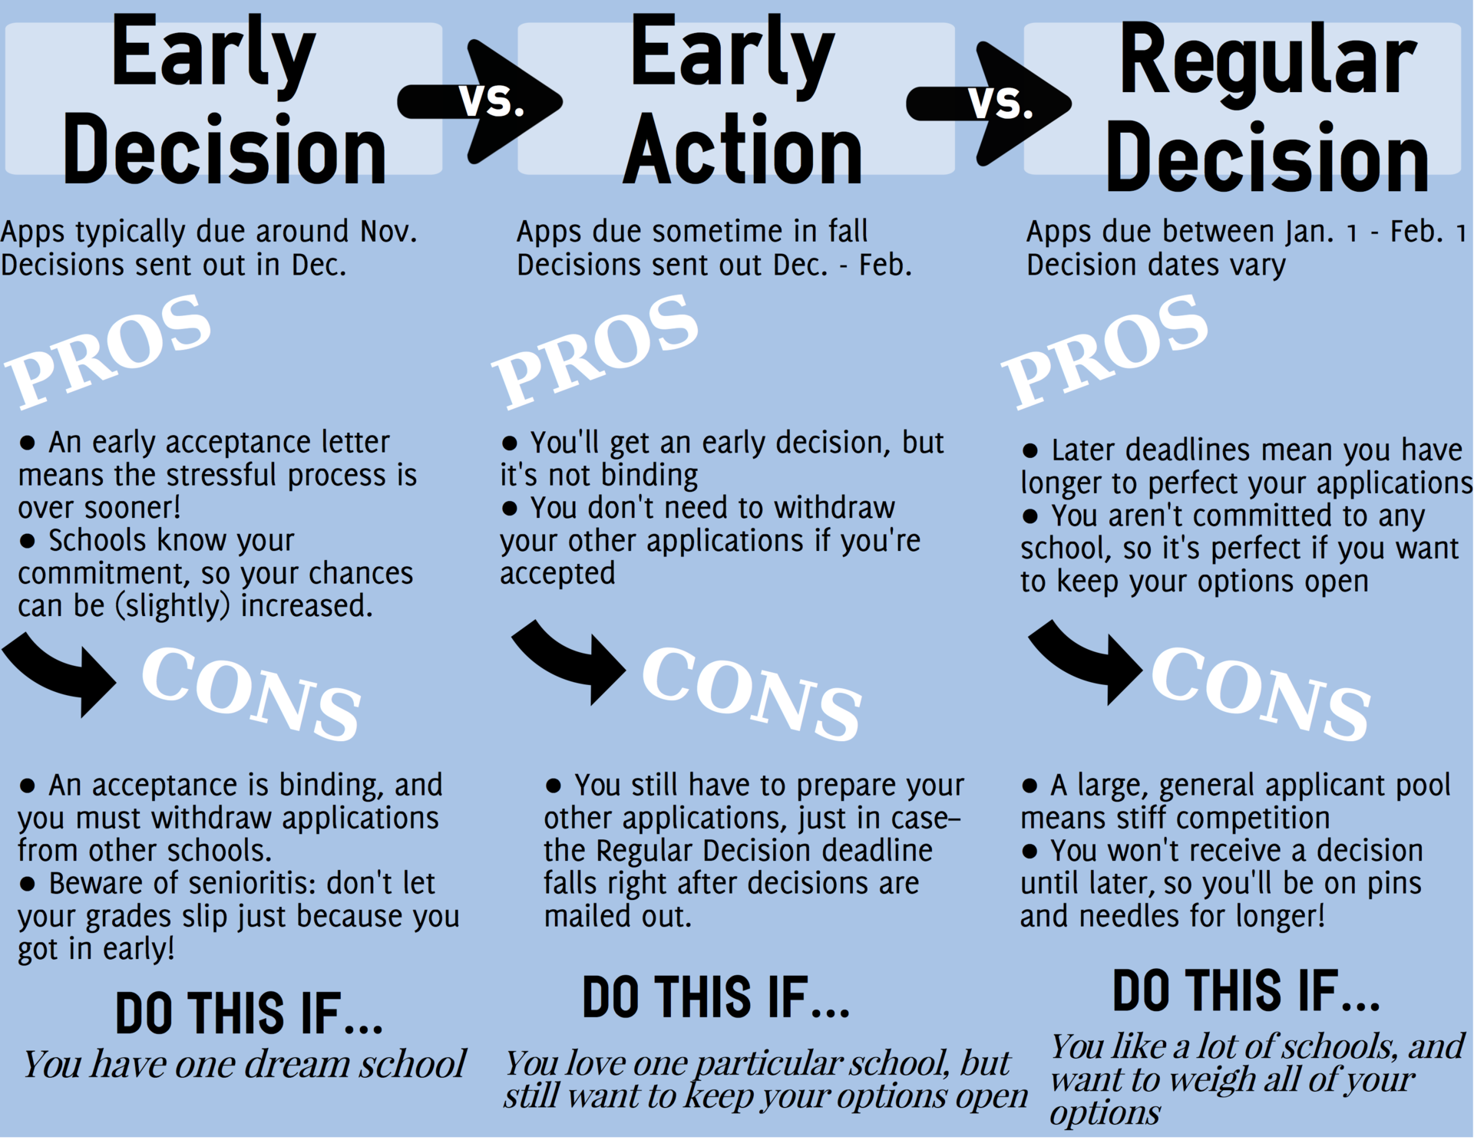

## More insight into decisions:

Another Con of EA/ED: You have less time to work on your essays so

1. your essays may not as be refined as they can be if you apply RD.
2. You’re going to need to work a lot harder to make your essays good since you’re on a time crunch.
3. You can only apply **ED to ONLY ONE** school! So make sure you’re 110% committed to that school.
   1. It’s also very difficult (but not impossible) to back out of a school if you applied ED. But if you do back out, it leaves a bad mark on your record since you backed out of a binding commitment. Think of it as breaking a clause in a contract you signed.
   2. But a pro of applying Early is…

If you get in somewhere, you will have some security and be less stressed since you at least have somewhere to go too!

1. All schools offer RD but not all will offer EA/ED. Some may offer only offer EA or ED while other schools may offer all three.

Examples:

-UC’s and University of Washington: Only RD, no EA or ED.

-Upenn: RD and ED only

-Oregon State: RD and EA.

-Santa Clara: RD, EA and ED

You can be **RESCINDED** if you don’t keep your grades up! For some schools, if you apply RD, you just have to maintain all C’s but for other schools, you can get rescinded just for getting a C, especially if you applied ED/EA.

There are **FEWER** applicants if you use ED/EA so you have a slightly higher chance of getting accepted. It will still be **COMPETITIVE** but you may have it a little easier.

**Ex: Harvard**

**(Statistics courtesy of the** [**Harvard Crimson**](https://www.thecrimson.com/article/2022/4/1/admissions-class-of-2026/) **and** [**Crimson Education**](https://www.crimsoneducation.org/us/blog/admissions-news/harvard-acceptance-rate/)**)**

Based on data for the class of 2026.

**ED applicants: 9406**

**Accepted: 740**

**ED acceptance rate: 7.9%**

**RD applicants:51,814**

**Accepted: 1214**

**RD Acceptance Rate: 2.3%**

**Overall acceptance rate (ED/EA & RD): 3.2%**

**Another example:** [**Boston College**](https://www.bc.edu/bc-web/admission/apply/early-decision.html) **(since not everyone will apply to Harvard but may apply to schools with similar acceptance rates to BC).**

The Advantages [of ED](https://www.bc.edu/content/bc-web/admission/apply/early-decision.html)  
[fall 2026 data (2021-2022 college admission cycle)](https://www.bc.edu/bc-web/admission/apply/admission-statistics.html)  
1st link is about ED, 2nd link is about overall admissions.

**ED applicants: 4,428**

**Accepted: 1240**

**ED acceptance rate: 28%**

**RD applicants: 40,500**

**Accepted: 6748**

**RD Acceptance Rate: 15%**

**Overall acceptance rate (ED/EA & RD): 16.7%**

**51% of the class was filled through ED.**

-Another advantage of EA/ED is that it may not be the end of the world if you **DON’T get accepted.**

**Deferment**: You are put into the RD pool of applicants. ( kind of like the early version of being waitlisted).

-Sign that your application was strong but not as strong compared to other applicants but strong enough that the school still wants to consider you for acceptance. Still difficult to get accepted but you have a second chance.

# **Essays:**

**TLDR**: SHOW don’t TELL, SPECIFY. Brainstorm, outline, draft, revise, cut, repeat. Keep it Simple. Cut unnecessary details/words.

# Things to know

**SHOW, DON’T TELL.** (you’re going to hear this a lot till you get sick of it so be prepared)

Essays from admission officer perspective: **Opportunity to get to know students better.**

Make the essay personal to your experiences. Readers want to get to know YOU so share a STORY from YOUR LIFE.

They enjoy reading the essays!

Don’t REPEAT what you mention in your activities list but you can EXPAND on your extracurriculars ( more on that below).

Essay reading is SUPER SUBJECTIVE. One school’s admission reader may love your essays while another school admission reader may despise it!

Can’t control **how readers interpret** your essay but **you can control** how you share your story to get the interpretation you want.

## 

## **Brainstorming topics:**

## Figuring out what to write.

1. Look at the essay prompts and find ones that
   1. -interest you (if you’re actually interested, you will write better)
   2. -If you think you have something that answers the prompt you could write about
2. List out potential topics you could write about.
3. Highlight/bold/underline the idea that
   1. Best relates to the prompt
   2. You have the most/enough substance to write about
   3. You feel a lot of passion about (not necessarily the one you’re most passionate about depending on the above two factors but it can be)
4. (if needed). Brain dump if you are stuck between multiple ideas. Get your ideas down and see which one meets the criteria above.

## **Essay Content Insights:**

You **DON’T**  need to have experienced hardships/large accomplishments to write a good essay. Things you do in your daily routine can make for good topics as well. None of my essays focused on hardships or large accomplishments.

-**Victor > Victim.** If you do write about hardships, talk about how you overcame them.

Readers want to see that you don’t succumb to challenges, can persevere and adapt.

IF you can think of a topic that is outside of the box, that can work really well but it’s not necessary.

IF you can write about a topic that is outside of the box in a way that is digestible and engages the reader, you’re in great shape!

Find something that you are passionate enough about that you can write an entire essay about it. Do you have something to write about and if so, do you have enough to write about?

## Starting the essay:

So you are ready to start your essay and begin typing. After 15 minutes, all you have is a blank white screen on google docs.

How to start:

1. Outline your essay

* Intro (thesis)
* Body paragraphs
  + Note down what each paragraph will be about
  + List the flow of the body paragraphs (in what order will you address each topic?)
* conclusion

1. Braindump
   1. Write all your ideas down on the page. Don’t care about anything else except getting your ideas down! Ignore word count, grammar, spelling, punctuation, etc ( pretty much everything you’ve ever learned to do in English)
   2. [Writeordie](https://writeordie.com/). (a website that forces you to keep writing unless you want to get blasted by an alarm. Helpful during the brain-dumping process. Shout-out to my English teacher for introducing this).
2. Cut
   1. Look for the ideas that connect to your thesis but also best discuss what you want your essay to be out.
   2. Start polishing up the writing.

Tip: Always cut and don’t try to expand afterward. I regrettably tried that by trying to turn my shorter essay into my longer Common App. Do it the other way around. Why?

-You already have your ideas down in the longer essay so just isolate some of the ideas further and work on your wording.

-Expanding can make your essay worse because adding ideas may muddle the focus, adding more sentences may disrupt your essay’s flow, etc.

### 

## Why Us essays

Ah, the dreaded Why Us essay.

Tips

1. Research the school thoroughly!!! **Why does the school appeal to you?!** 
   1. Any specific class(es) that interest you? Something you like about their curriculum? Unique opportunities such as research, study abroad programs, etc. Chance to work with an acclaimed professor in a certain field? Something about the school’s curriculum that stands out to you?

You will write a better essay if you’re actually really interested in attending, unlike me who was interested in attending the schools that asked the Why us (BU and SCU) but they weren’t my top choices.  
 -Narrow down your reasons to 2-3. You usually will have 250 words for these essays, maybe more or less depending on the school so select a few reasons. (2-3)

1. Be Authentic and genuine!
   1. It’s clear when you’re writing the essay half-heartedly and bs-ing it so readers will likely pick up on it. Even if you mention something in a specific detail, like a class you want to take or a professor you want to work with, it’s still noticeable that you’re just mentioning it to sound like you’re more interested than you actually are.
   2. You will probably know it yourself when you’re writing. My SCU and BU essays were not the best partially because I wrote them half-heartedly. So don’t make my mistake of not trying your best on these essays.
2. **DON’T** write that you want to attend the school because it’s prestigious, good, etc because the schools already know that!

TLDR: PERSONALIZE the essay! EXPLAIN What about the school makes **YOU** WANT to attend!

## Expanding on your extracurriculars



**REPEATING** is listing again what you did on an extracurricular in your essay(s). **EXPANDING** is narrowing down and focusing on a few specific aspects of your experiences with an activity.

Don’t: In this club, I was president and organized a presentation about mental health.

Do: As president, I took the lead in organizing a school-wide presentation to other students about mental health. I coordinated with school administrators to work out logistics and develop a plan to advertise the presentation. I would constantly be emailing and meeting with administrators to ensure all of us were on the same page. Although it was tedious to be constantly going back and forth with my school’s principal on a daily basis, I found it necessary to do so if I wanted to have the presentation run as smoothly as possible.

Things to note:

-Goes into specific details

-focuses on a specific aspect of the club, the presentation but also narrows down further on that specific activity within the club.

Club->activity->organizing activity.

This is just a hypothetical example btw but here’s an excerpt from my essay about summer camp counselor experience, which is obviously extracurricular. (Aka, ⅔ of the actual essay).

“While I’m not as energetic as most kids, I’ve bonded with each camper I’ve worked with by discovering our common interests. For example, one group of boys mentioned that they liked baseball, and from then on, we conversed about the sport every day.

After I shared my interests with the kids, they slowly began to open up to me. This allowed me to further get to know them but also strengthened my role as a leader. Instead of viewing me as an authoritative figure, they saw me as someone who genuinely cared about their wellbeing.

In addition to bonding with the kids, I also established lasting relationships with my teammates. I frequently offered my assistance, demonstrating that I was willing to take the initiative to support them. Like the kids, my fellow counselors opened up to me more as our trust in each other grew. For instance, a couple of counselors and I had an in-depth, personal conversation about our empathy for the kids. As a result of the intimacy built between my co-workers and I, we worked better together in the common goal of giving the kids an exceptional experience.”

The thing to note:

- focused on the relational-building aspect of being a counselor, both with the kids I worked with and with counselors.

-talked about the effects of my action. SHOW both what you did but also how your contributions made a difference.

## Writing style:

### **How you write>what you write about**

You can talk about the same topic as anyone else but what sets you apart is how you present your story. Ex. I talked about public speaking in my common app essay and one of my UC essays which is not necessarily too unique of a topic.

Vice versa: You can write about the most unique topic but if you don’t write about it well, it’s not going to do you much. Shoot, you can write about how you won first place at a national competition or somehow discovered a new species but if your essay is really boring/confusing…yea.

**KISS** the essay: Keep it simple, silly (or stupid, I’ve heard both so use whichever you like better).

-No need for fancy vocabulary. Admission officers will actually pick up that you’re trying to sound extra sophisticated and it can backfire by confusing them.

-Use details but no need to go super in-depth. Just be detailed enough to get your story across.

* SYNTAX:
* Can you say the same thing in fewer words?
* Active voice > passive voice
  + Fewer words so more direct but more exciting to read.
* Don’t turn verbs into nouns
* General rule for writing: the more specific, the better. Include anecdotes and concrete details when you can. (SHOW>TELL)

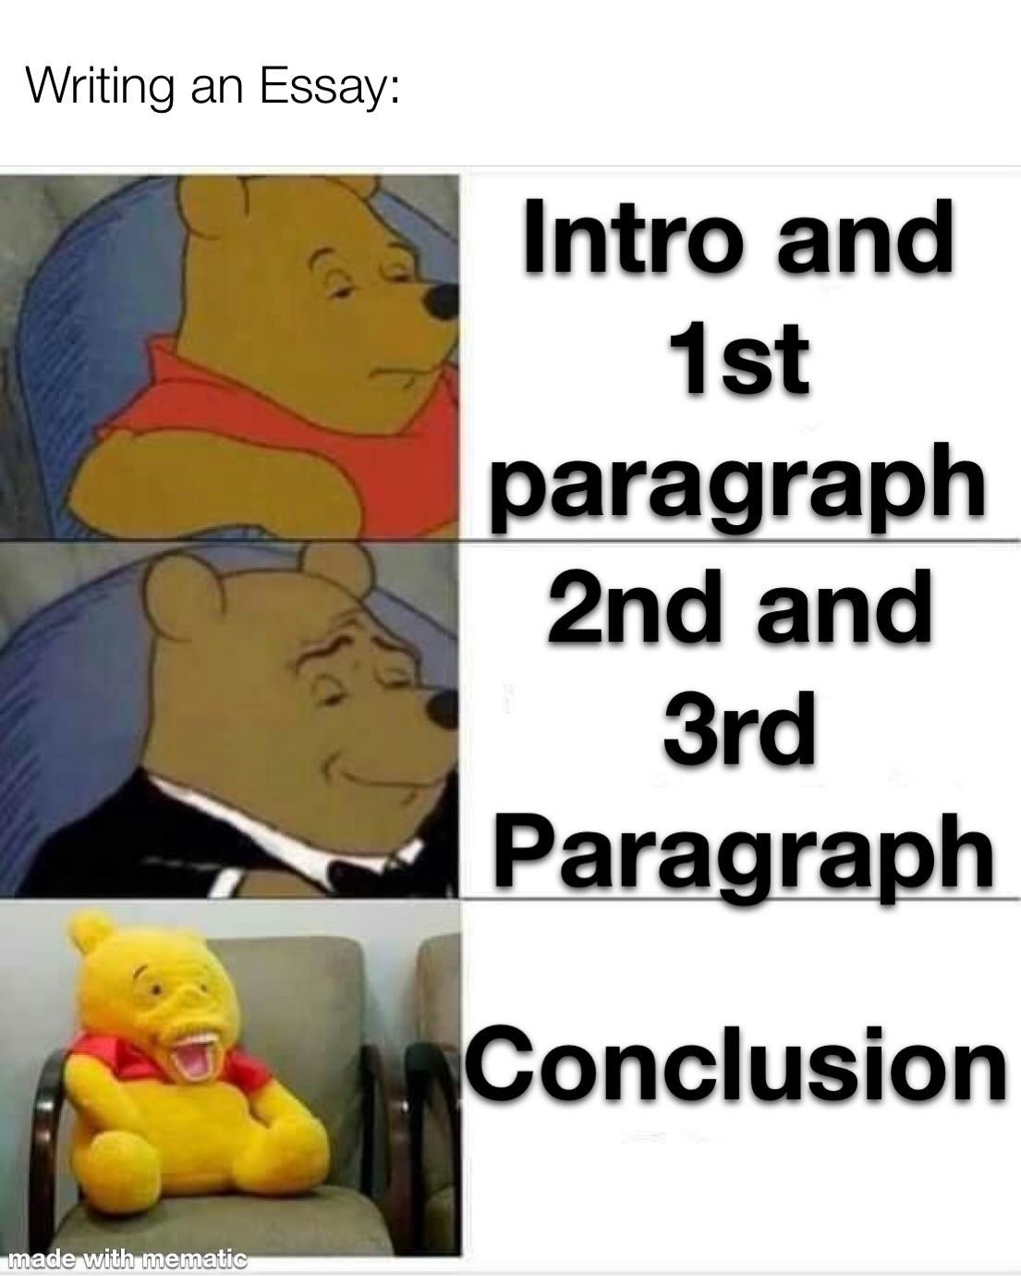

## Writing strategies:

*There are obviously other ways to write essays but this is how I mostly wrote mine.

### **Intro**

Anecdotal lead (Hook) and en media res (begin in the middle of things)

Jump right into the action and give a reader an idea of what is going on and tease the direction of the essay. Paint a picture of what was happening around you at that moment.

5 W’s.

Describe a scene from the experience you’re writing in your essay.

OR introduce the topic straight away.

Keep it short, 1-3 sentences. You only have so many words so don’t use a lot on your intro.

Examples:

From UC prompt 2 about creativity:

“In a torrent of clickety-clacks on the keyboard, lines mold into stanzas on my computer’s bright screen which pierces the dim lighting in my room. “

From UC prompt 6 essays about academic interest:

“I was first introduced to the concept of climate change when I read an *Eyewitness* book in second grade. Seeing charts showing the exponential increase of Earth’s average temperature and images of starved polar bears stranded on ice floes horrified me at such a young age, but those images also sparked my passion for learning about Environmental Science.”

### **Body Paragraphs:**

Write things in Chronological order.

Keep expanding. Build each paragraph off of one another.

Have each paragraph focus on a different topic. Don’t repeat topics within paragraphs.

-SPECIFY! Mention events, projects you did, and experiences, in these paragraphs to provide examples you can elaborate on!

### Conclusion

Be reflective and introspective

Talk about what you learned from your experience AND how you plan to apply it in the future!  
Tie it back full circle. Connect your lessons to what you previously mentioned

Show you really learned from your experience and have a growth mindset but demonstrate you have a vision of how you can apply what you learned to other scenarios.

Keep it practical and realistic though and make sure that it can tie back to the rest of the essay.

Works really well if you actually have an idea of how you can apply those experiences.

**Examples**:

Example 1: From Prompt 1 UC essay about leadership and how working as a summer camp counselor taught me the importance of being proactive in building relationships with your colleagues.“Looking ahead, I believe the proactive relationship-building skills I developed are applicable to my future career. I envision myself meeting new colleagues and establishing a network to do what I did when a counselor, reaches out, and demonstrate I care about the well-being of those around me.”  
  
Example 2: From prompt 3 UC essay about skill developed over time/common app essay about an interest in public speaking.   
“Looking introspectively, I want to use my public speaking skills to educate others about how they can help the environment. A goal of mine is to give presentations about how people can combat climate change in their daily lives. I believe I can inspire others with my words and I intend to do so.”

### **The Inverted Pyramid**

The idea is to state what is NECESSARY in getting the point across before getting into details:  
Extremely helpful in making your point concise while also saving words!

## **Cutting tips**

1. **Again,** Active voice > passive voice  
Rewording/Rephrasing by using an Active voice saves a lot of words!

2. Forget the Fluff! (FTF)  
delete any “descriptors” (adjectives, descriptive sentences, etc) In this order. (Cutting adjectives can cut down quite a bit of word)  
Any additional details that are not needed but nice to have (bottom of the inverted pyramid)

Yes, it’s hard, but unfortunately, you can’t exceed the wordcount :(  
  
Deeming what is necessary

Ask: Is this detail **ABSOLUTELY NEEDED** to convey my point?  
Is it something I have already mentioned previously in my essay? Is it NEW or builds off a previously made point?

**Ultimately**, Use the strategies that work best for you!!!

## **Making essay writing time:**

Yes, it’s hard to balance writing essays alongside homework and extracurriculars but here are some time management tips from my application/collegiate experience:  
  
1. USE a PLANNER/CALENDAR!  
-Schedule designated times into your week to work on your essays.

-Hint: Empty chunks of time are great times to get tasks done  
2. Set goals on what tasks to accomplish during the time you work.  
-Ex. -Braindump for one essay prompt  
-Complete a rough draft of an essay  
-Address half of the comments from a recent review session  
-Cut down on words for this essay

Focus on addressing specific points of your essay rather than risk jumping around too much.

## 

## **Additional tips**

It’s ok to recycle your essays and use them for other apps! Essay prompts are pretty similar so you can likely edit an essay to fit into another app/school’s prompt. Personally, I turned two of my UC essays into the two supplement essays I needed to write for CU Boulder.

Less work and stress as well! :)

Get feedback from multiple perspectives! (peers, counselors, teachers,counselors, trusted adults, etc) Yes, it may be difficult to share your work and not take feedback personally( I struggle with that tbh), know it will help you improve your essay! And people do want to help you!

Be careful though about having too many cooks in the kitchen. Feedback is great but having too many opinions on your essay can actually hurt since opinions may conflict!  
**ANSWER the PROMPT**You can write the greatest essay ever, but if you don’t answer the prompt, readers will ponder if you read the directions or not.

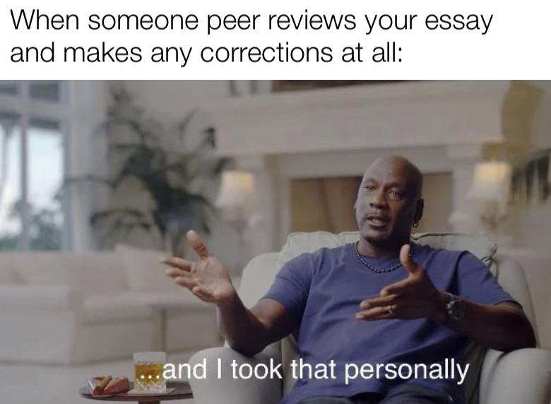

## Essay resources:

[Writeordie](https://writeordie.com/) (I listed it above but if you missed it, here it is again)

[College Essay Guy breakdown of each Common App essay prompt with examples](https://www.collegeessayguy.com/blog/common-app-essay-prompts)

(Prompts didn’t change from last year)

[Same thing but for the UC essays!](https://www.collegeessayguy.com/blog/uc-essay-prompts)

- [Former UC admission officer playlist on writing the UC essays](https://www.youtube.com/watch?v=txjF_PTMvDo&list=PLH_BDhGTiU7S1XA3VmpOvqWpKP23aUbd3)  
 - [UC essay breakdown by UC admissions](https://admission.universityofcalifornia.edu/how-to-apply/applying-as-a-freshman/personal-insight-questions.html)

[And for the Coalition app essays](https://www.collegeessayguy.com/blog/coalition-application-essay-prompts-examples)

[Additional tips on extracurricular essays](https://blog.collegevine.com/extracurricular-activity-essay-examples/)

[More examples of extracurricular essays](https://www.collegeessayguy.com/blog/extracurricular-activity-essay-examples)

[Why us essay tips](https://blog.collegevine.com/how-to-write-the-why-us-college-essay/)

[A teacher reviews their college essay tips](https://youtu.be/_PhK7n4Labg)  
 [Guiding questions for common prompts](https://www.weareteachers.com/college-essay-prompts/)  
 [Essay Intro and conclusion tips](https://youtu.be/E5SmMV9-UbM) [Harvard essay tips](https://summer.harvard.edu/blog/12-strategies-to-writing-the-perfect-college-essay/)  
 [More Harvard essay tips](https://youtu.be/Xz94wRwFOCI) (video)

3-part podcast episode series of how Yale admission officers review essays (also a great general resource)

[Part 1: What works](https://open.spotify.com/episode/0efQOnRCH8UVkdd0Hx2Vfe?si=67230e9361934026)

[Part 2: What doesn’t work](https://open.spotify.com/episode/6f99vibOrc4XUUFu792GsG?si=906c720cefad42b9)

[Part 3: how essay prompts are written](https://open.spotify.com/episode/4xQfYvMkDE1qJRzcA8Vnao?si=5503004a29274daa)

[Comparing UC essays that worked vs didn’t work (rejected vs accepted)](https://youtu.be/MEqlUq2ayYQ)

Supplements: Look up [insert school] supplement essay examples and plenty will pop up, along with tips on writing them!  
[Khan Academy college essay unit](https://www.khanacademy.org/college-careers-more/college-admissions/applying-to-college/admissions-essays/v/writing-a-strong-college-admissions-essay)

[C2 Education college essay webinars](https://www.c2educate.com/webinars/)

[CollegeRaptor](https://www.collegeraptor.com/)

[ShemassianConsulting](https://www.shemmassianconsulting.com/)

[CollegeAdvisor](https://www.collegeadvisor.com/resources/examples-of-college-essays/)

[PrepScholar](https://www.prepscholar.com/)

[Supertutortv](https://m.youtube.com/user/SuperTutorTV)

-[4 ways to ruin your college essay](https://www.youtube.com/watch?v=OJdjkESHK-8)

[Common app essay tips](https://youtu.be/0RIJDpxeTU4)

[UC essay tips](https://youtu.be/F7CHww0JeUY)

[A playlist of college students reading their essays](https://youtube.com/playlist?list=PLZFFRGFa2FwNW62c-OtlLc7mSjJyosWl-)

# **Letters of Recommendations (LOR’s):**

**TLDR**: ASK EARLY and Don’t PANIC if you don’t see the LOR submitted on your application.

## 

Ask Early!

-Don’t wait until the last minute because your teachers/counselor needs time to write the letter. This is really important when asking a teacher because they are busy with their lessons and can only write so many letters so they may start turning students away after a certain number of requests/if you ask too late so ask early!

September-mid October would be a good time to ask. At the latest, early November.

-Storytime: The teacher I asked for my letter of rec said that I was the 12th student who had requested a LOR and they said that once they got to around 20 students, they would start turning people away.

-Fill out any documents that they may ask to help write the letter. The counseling department may have a form where they ask questions about themselves to help counselors/teachers write your letter better and therefore, write a better essay for you!

-Know they want to help you! Admittedly. It was scary asking for a letter of rec but once I asked, I could tell the teacher and my counselor wanted to help me succeed.

**TLDR**:  
 Ask EARLY (September-Early November)  
Ask someone who you have had multiple times or who teaches a subject related to your intended major

**Something colleges may require**

Some colleges require that your LOR comes from a teacher who taught you during your junior or senior year. Their reasoning is that those years are generally when you take the most AP classes/harder classes in general so they want to gain your teacher’s perspective on how you handled the academic rigor of those years.

Ask Politely!

Email ahead of time if it’s a teacher you don’t currently have but had in the past. Same for counselors.

If it’s a teacher you have, ask when they are free, such as the beginning of class if they aren’t preparing their lesson or after class, or during office hours.

KISS (keep it simple silly/stupid). the ask: Hi [insert teacher/counselor]. I’m working on my college apps right now and I was wondering if you could write a letter of rec for me?

Thank them after your ask, even if they decline!

## Asking teachers

**The most important factor in my opinion: Is to ask**

1. a teacher you’ve had for many years since they know you well since they’ve got to interact with you more often than other teachers. Also more likely to not write a default letter since they can make it more personal.
2. You can also ask a teacher who teaches a subject that relates to your major. Ex. If you’re majoring in history, you can ask a history teacher you had. If you’re majoring in engineering, you can ask a physics/math teacher.

If you can find a teacher who you’ve had/known for multiple years AND teaches a subject related to your major=GREAT!!!

## Asking counselors

## Try to formally schedule a meeting with them to ensure that you have secured time to meet with them. You can try dropping in but they may be in another meeting so it’s better to book your appointment. Asking “Mentor” figures

Less commonly known is you can also ask people who “mentored” you someone to write a letter of recommendation. Examples can be an adult you worked with during a summer program, a sports coach, an extracurriculars teacher, etc

**Things to know**

Colleges know that counselors have a lot of LORs to write so counselors are actually given the option to submit the LOR and other documents after the application deadline.* So while you may have to turn in an app by Jan 7th, your counselor actually can turn in your LOR a few weeks later.

*I know this applies to Regular decisions but not sure if this applies to Early Actions/Decisions.

The point?: Don’t panic if you see that your counselor hasn’t submitted your LOR yet, especially after you submit your app. No need to spam their inbox or run into their office every day asking if they have submitted your LOR yet.  
  
LOR checklist

* Research schools
* Check which schools require a LOR(s)  
   -See if they have specific conditions (certain number, certain subject, a teacher from a certain grade, etc)
* Brainstorm teachers you can ask  
   -Check if your school provides a document you need to fill out with info about yourself beforehand. Some counselors/teachers may require this!
* Reach out to the people you want to write your letter! (Counselor, teachers, mentors, etc)
* Thank them when/if you receive confirmation they have finished your letter
* Let them know which school you end up committing to

[Additional advice](https://www.youtube.com/watch?v=AGwvuFNHxeg&ab_channel=IrisFu)

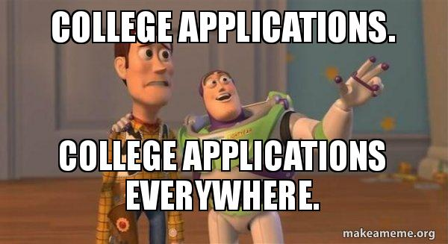

# **Other misc tips/insights**:

TLDR: Be resourceful but also research thoroughly

### Utilize the resources around you!

-Utilize application planning and essay review services provided by your school (Counselors and volunteers, etc)

-Ask teachers to review your essays!

-Attend webinars, seminars, info sessions, etc that your school hosts!

-Listen to your teachers if they provide advice

(Free Info is free info)

A good portion of the advice I’m sharing comes from attending webinars :D  
THE INTERNET! There are plenty of additional [FREE] resources out there!

### A sneaky way to (maybe?) slightly improve your chances at admission.

(Especially if you’re pursuing impacted/competitive majors).

**Put on your application a major similar to what you actually want to do.**

Want to do Pre-Med? Put something not as common like Public Health, or even better yet, put something, even more, niche, microbiology, or psychobiology (if it’s offered of course).

Or Comp Sci? Consider putting Information Systems, Information Technology, etc. (maybe not software engineering since engineering is also highly impacted)

Why? Since these majors are similar, you will likely be taking most of the same GE’s/pre-req classes except you might have a slightly easier chance of getting accepted since

1. Your major is more niche so there are fewer applicants and therefore, less competition
2. It’s not impacted so there’s not as much limited space for it.
3. Schools are seeking diversity in terms of the number of students of certain majors they accept. They can’t accept all CS majors or all Business majors lol!

You can then change your major and it should be slightly easier since you took most of the GE/Pre-req classes like anyone else would for that major.

**BUT** research the course-required alternative major and how it compares to the major you actually want to pursue to make sure the GE/Pre-req classes are actually similar. If they are not, you actually might be digging yourself into a hole.

## **AND** if there is no good alternative to your intended major, just stick with it. My take on the “Applying as a humanities major and changing majors later strategy” Statistically, humanity majors generally have a higher rate of acceptance (school dependent though) So yes, technically, it is “easier” to get in. But the risk with applying as a humanities major and trying to switch to a non-humanities major is

**Difficulty switching**  
You may have a hard time getting into the classes required to switch, whether it be school/department/major restrictions, etc (dependent on the school’s change of major policy)  
+More impacted majors (Engineering, CS, Business) may have caps on the number of students allowed to change into the major anyway (again, varies by school)  
So there’s a likelihood you may fall behind on getting your degree even if you end up switching depending on how long the change of major process took.

Doable, but possibly difficult

**Moral argument:**  
You may be taking away a spot from someone who actually wants to pursue the major you applied just to switch

**Final take:**Research andapply at your own discretion  
  
(Getting accepted is one thing, actually pursuing your intended major is another thing)

## Putting down an alternative major

**Yes**

1. If you don’t get in for your first choice, you can at least get in for your alternative. If you put nothing, then you take away that option of at least getting in for something else.
2. You can always change majors as well ( I would suggest looking at how to change majors though because the process varies by school, and it can be easier or harder depending on the institution.  
   +You may end up realizing you like your alternate major more than your primary

## ChatGPT?

Should I use CHATGPT to write my essays?

**NO!** Because

-AI lacks emotions. It may be able to tell a story but it won’t be personal to YOU! Only you can convey your feelings, thoughts, and experiences truly to a reader. AI may make it sound more sophisticated but there’s no actual weight to the words.

-Sentence structures are similar and recognizable

-Possibility of Plagiarism detectors

BUT you can use AI as a brainstorming tool

-by asking it to provide guiding questions

-summaries about specific programs within a school

## 

## 

## Build a support system

You don’t need to do this alone! Ask your friends for help but ESPECIALLY ask any friends who are in college for assistance since they can provide extra support and advice!

Also, reach out to your counselor, and teachers for help as well!

#### **Final thoughts**

You don’t need to be a 4.0/4.5 weighed student, take 15 AP’s, involved in a bunch of clubs/student body, hold 10 different leadership roles, involved in outside school organizations, or be an entrepreneur, to get into a “good”, highly ranked school. Shoot, look at my background info. It’s helpful but it’s not the end of the world.

If you are a student like this though, I can’t wait to read about you when TIME magazine publishes its annual 100 most influential people list. But seriously, It’s great you are passionate about many subjects.

If this helps a little bit, this was my mindset during college apps, especially when decisions rolled around.

A school will see your worth! It may not be your 1st choice, but a school will recognize what you could bring to them!

Rankings are extremely SUBJECTIVE so they not the best source. Each site has different criteria so Princeton may be #1 according to US news while Cal is #1 according to Forbes.

Can be useful if you are willing to look into the ranking criteria (esp Forbes)

And schools have been dropping out of the rankings ever since Columbia was caught fudging statistics to obtain a higher ranking…  
**Articles about the ranking situation**  
[Columbia University gave incorrect data for US News college rankings (usatoday.com)](https://www.usatoday.com/story/news/education/2022/09/12/columbia-university-incorrect-data-us-news-college-rankings/10358383002/)  
[These Colleges Dropped Out of U.S. News Rankings | BestColleges](https://www.bestcolleges.com/news/these-schools-dropped-out-of-us-news-rankings/)

But in all seriousness, I wish everyone reading this the best of luck and I’m rooting for you all to get into a school you want to be at! Tbh, I think many of you have a better chance of getting accepted into schools since a lot of you probably are stronger academically than me but I’m rooting for your success! :)



# **Additional resources:**

[Crashcourse video on applying to college](https://youtu.be/m_9S5cBNvTs)  
[College admissions Khan Academy course](https://www.khanacademy.org/college-careers-more/college-admissions)  
[Old Khan Academy college app channel](https://www.youtube.com/@collegeadmissions1844/featured)

[Former UC admission officers interview](https://youtu.be/tjtfeqv_yfA)  
[73 questions with a former Ivy League admission officer](https://youtu.be/2i4lSMpG7Rk) (Skip to 2:21 for admission-related questions)

[Former UC admission officer YT channel](https://www.youtube.com/@maiakrause/videos)

[Inside the Yale Admission Office](https://open.spotify.com/show/4rZtfCyIZEfAVkg7aHzhzC?si=7eb85d0280da43e5)

Podcast by Yale Admission officers that opens up about how admission officers reveal applications while also clarifying some misconceptions.

[The College Admissions Process podcast](https://www.collegeadmissionstalk.com/)

[College Navigator - National Center for Education Statistics](https://nces.ed.gov/collegenavigator/)

Database with statistics about various schools. The site is not user-friendly but very useful.

[Assist.org](https://assist.org/) (a good site to look up majors at specific schools)

[Bigfuture.org](https://www.bigfuture.org/) (the evil empire known as the Collegeboard admittedly does have a solid site to help with navigating college apps)

[College advice presentation by my homeroom/registry teacher](https://docs.google.com/presentation/d/1Gx_WcF9ue07am_AKK7M3XFYs42L8AT-vkKYskBHxa84/edit?usp=sharing)

[Sheet made by a UCLA student and YouTuber to help organize all your research into schools](https://docs.google.com/spreadsheets/d/1SRamGE_W2d9YZS3olEUQyJgGigFdNupfy18vKJlhdbE/edit#gid=1564199634)

[-Accompanying video](https://youtu.be/iv4qWu_8sh0)

[Admission tips from many UCLA students ( by the same YouTuber)](https://www.youtube.com/watch?v=vIhEVkMKucU&t=88s)

[Ted Talk by a college admission expert. Long but quite insightful.](https://www.youtube.com/watch?v=h21OmjyviC4)

[College app advice by a current Princeton student](https://www.youtube.com/watch?v=vn3rqnkwVy8&t=608s)

[A MIT student’s college app advice](https://youtu.be/4EN1xpv6TM0)